CIF Israel Member Participates in CIF Finland PEP

By Gila Attal, CIF Israel

I have been a social worker for about twenty years and it was my first opportunity to participate in a wonderful CIF professional exchange program (PEP) in Finland. This was my first exchange program, my first time in Finland and it also happened to be my first time to celebrate Israel Independence Day out of Israel. I celebrated with the Jewish and Israeli community in Helsinki and I had the honor to meet the Israeli ambassador to Finland. Meeting and celebrating with the Jewish and Israeli people gave me the feeling of home and Finland became like my own country.
The day I arrived, waiting for me in Helsinki airport was Valpuri Sorri, who was the first Finnish lady that I met. From our first meeting it felt like we had known each other for several years.
We were three participants. The other two participants were from Spain and Tanzania (three people canceled at the last moment). We came from different cultures and countries. It was interesting to get to know each other personally, professionally and culturally.
The first week out of three weeks I stayed with my first host family – an interesting and wonderful woman living in Helsinki who was sensitive and aware of my needs. I learned about the local professional aspects of social work, social work methods and policies in the academic and in practice.
The second week each participant went to another area in Finland to get a chance to learn more in the professional field of interest. I went to Oulu to learn about the elderly welfare field. I had the opportunity to compare their system and method to what exists in my country. I had an exceptional opportunity to give a lecture about my work to professional staff and I also ran a workshop for a group of elderly people in a non-governmental organization (NGO) in the city of Oulu. I met with NGO volunteer organization professionals, social workers in agencies working with the elderly and visited a day care center. The last day in Oulu I was invited to join a free day with all the social workers which I enjoyed. It was a wonderful day!
The third week was in Helsinki where we had the evaluation. On that week we had a day off and so I went with my host family to visit Tallinn in Estonia for the first time.
During the program we visited famous places in the cities, we were introduced to social services and agencies and to other relevant information in order to better comprehend the welfare system. The program was very intense as well as interesting. I was very curious and wanted to learn more and more about the cultural and professional aspects, sites and places. Still, I was given time to rest when I felt tired.
For me personally it was a very welcome and interesting visit. I learned to know many different families who shared with me a variety of Finnish behaviors and lifestyles. We had Finnish sauna, ate Finnish food and even learned to speak a few words in Finnish.
All the hosts and the other participants were sensitive, understanding and considerate of my personal and professional needs. As a religious Jewish girl who keeps Shabbat and eats only vegetarian food, I do appreciate the understanding and consideration. All of them gave me warmth and a feeling of a home.
I thank them very much! Our good friendship continues from now and ever!
I would like to mention that before I left for Finland I received a big welcome and help from Leo Heikkilä, president of CIF Finland and from Edna, CIF Israel president. They both cooperated to advise me prior to my trip and even helped to get low-cost flight tickets. When I arrived in Finland I met Leo and realized even better what a wonderful person he is.
Before my arrival, I received e-mails from all my host families with a sincere invitation. This gesture arose my interest in getting to know each one of them personally. I was looking forward to meet those people who have sent to me a warm welcome, opened their home doors and hearts. Now, I’m looking forward to seeing them again as soon as possible. I have even started counting the days!
For me it was a dream… which I was able to fulfill by participating in a CIF program, traveling to this great, interesting country, to learn to know these wonderful people whom I will never forget. It was a great program! I thank the Finnish branch for their program and I recommend to everyone who wants to be enriched professionally, culturally and personally, to participate in a CIF PEP in Finland.

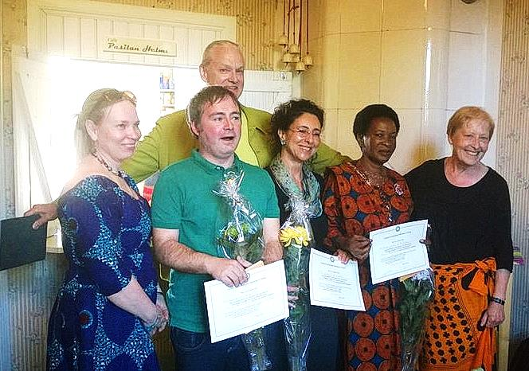
Final PEP party (Gila Attal - 3rd from right)

